**Abhidha Arya**

**Entity (table) description and SQL snapshots:**

1. Tables Created: The highlighted part shows all the tables created.

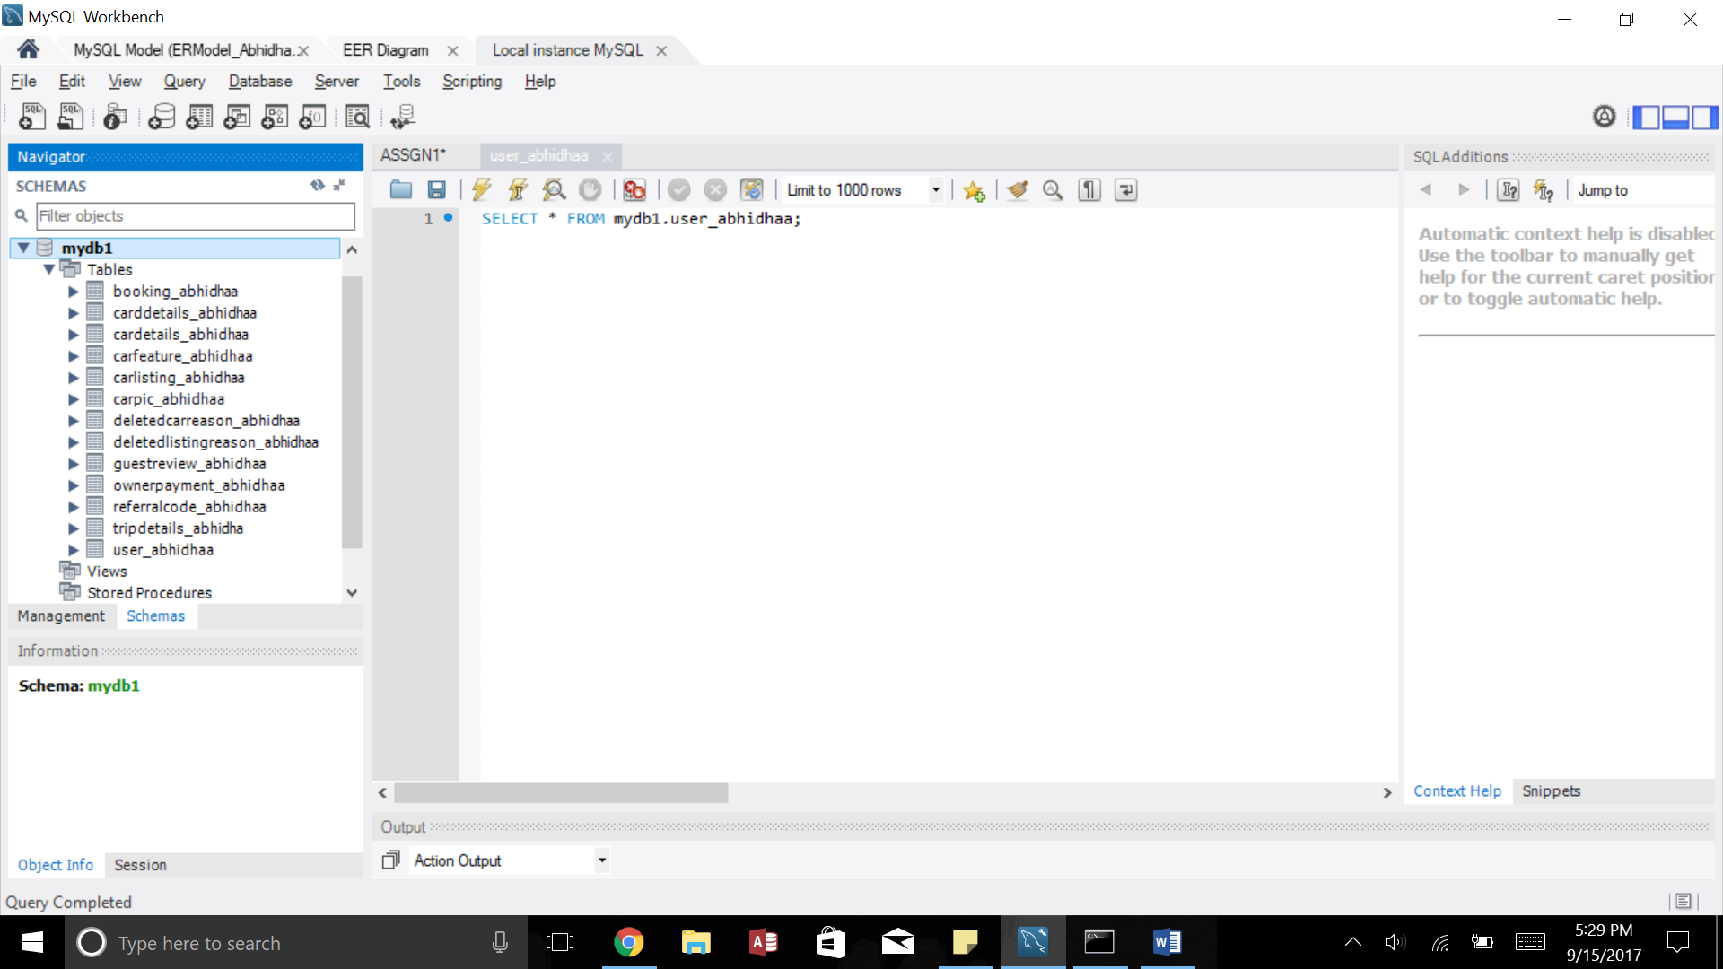

1. User_AbhidhaA: This table contains details related to the user. This table needs to be aliased because the User ID is acting both as the Owner ID and the Guest ID.

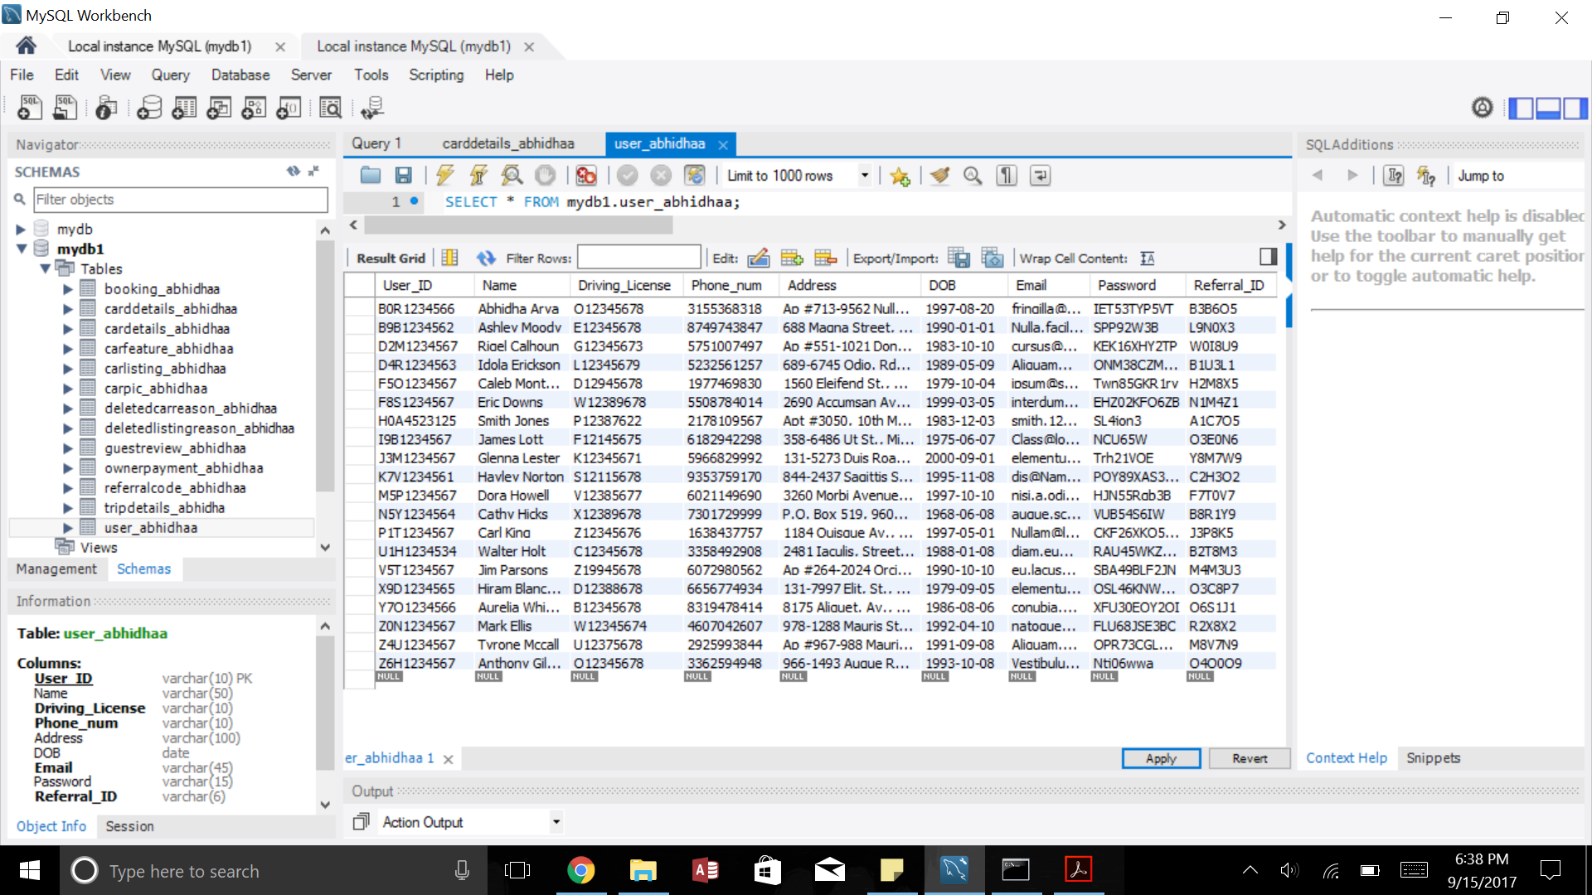

1. Booking_AbhidhaA: This table contains all the details related to the booking of a car. A booking record is generated only when the payment/transaction is done.

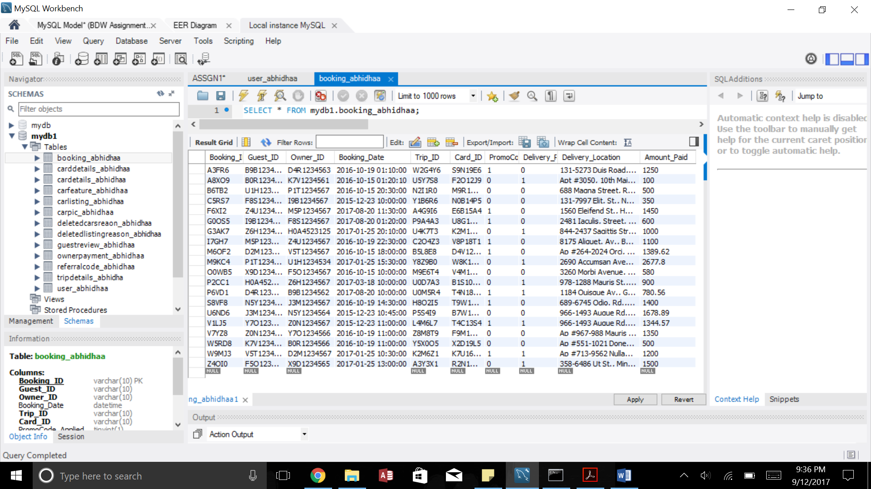

1. CardDetails_AbhidhaA: This table stores the Credit/Debit card details of the user.

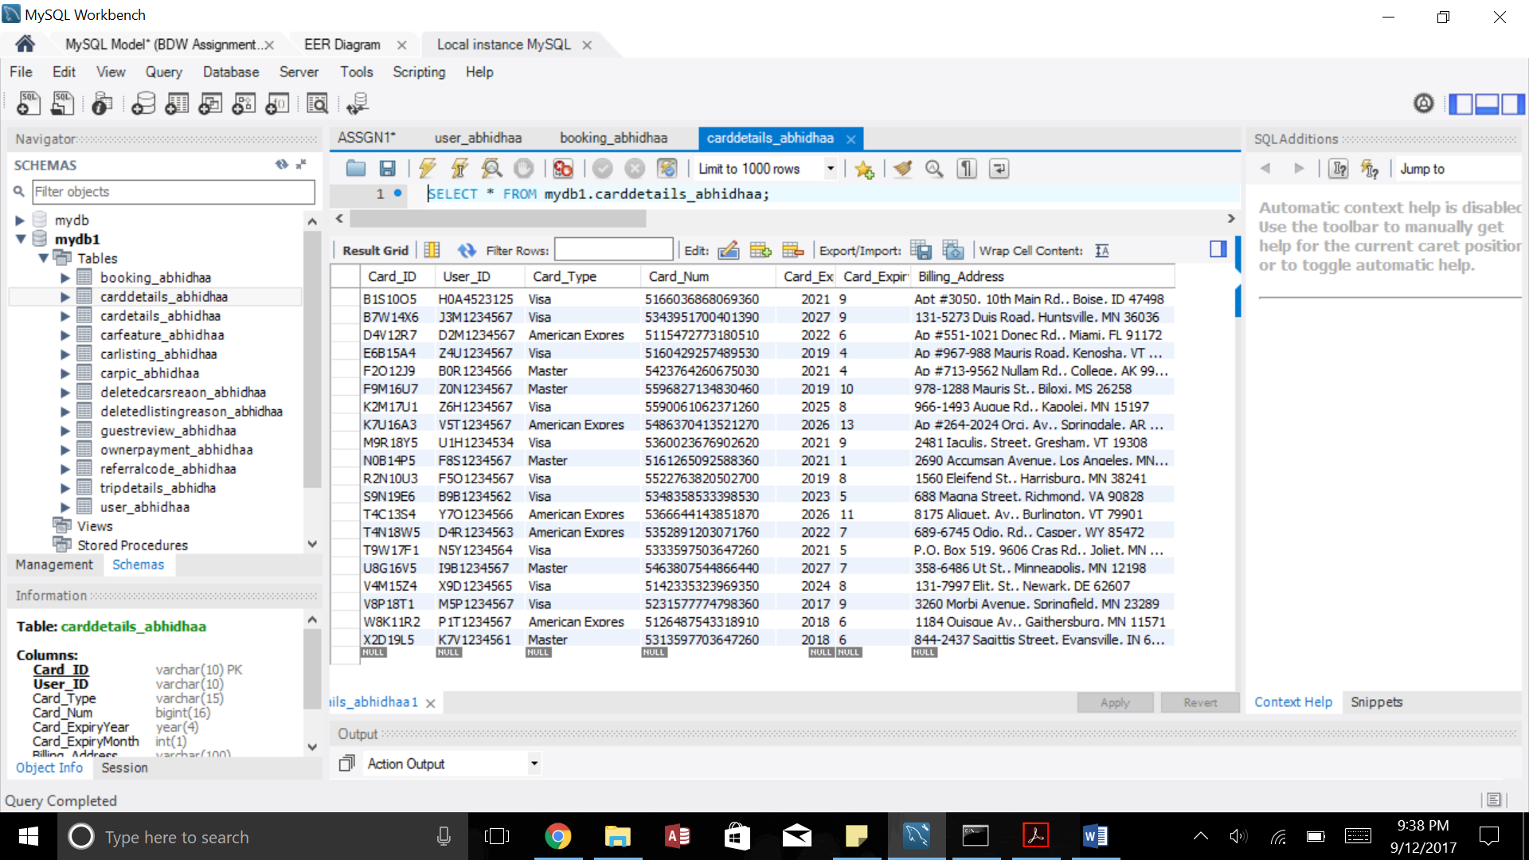

1. CarDetails_AbhidhaA: This tables stores all the details related to the Cars listed on the website.

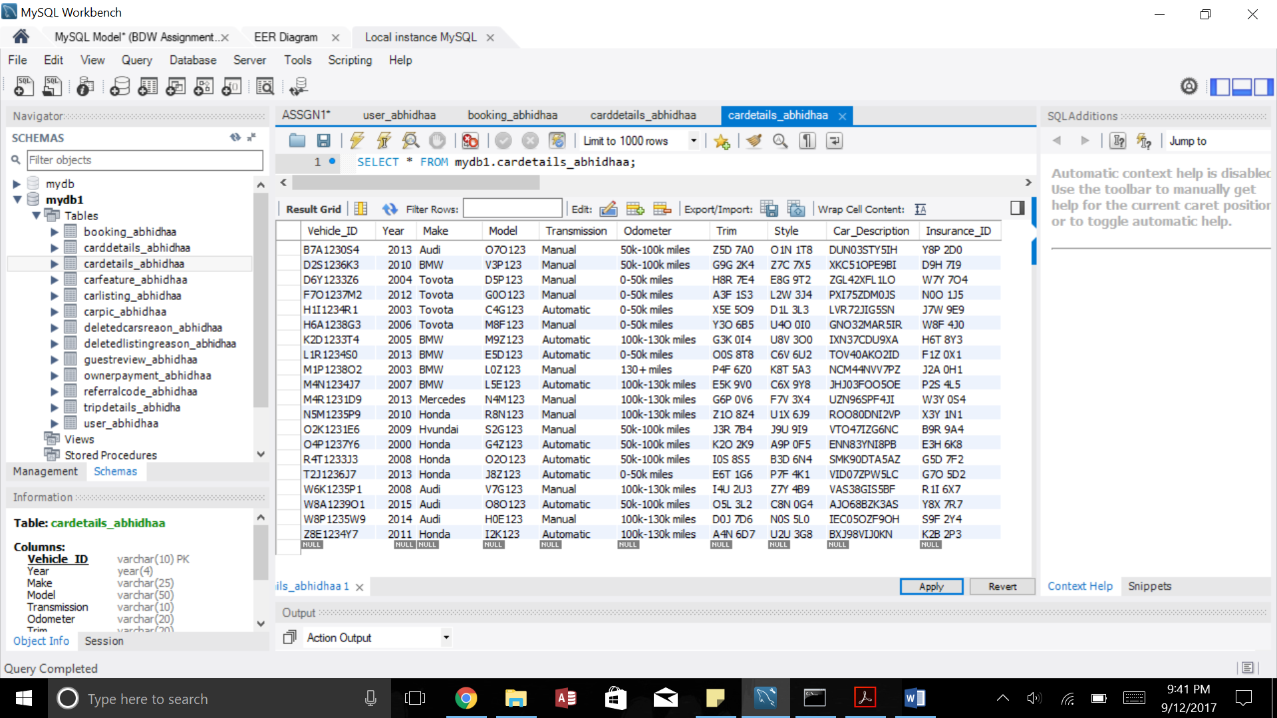

1. CarFeatures_AbhidhaA: This table stores the features of the cars; one car can have multiple features.

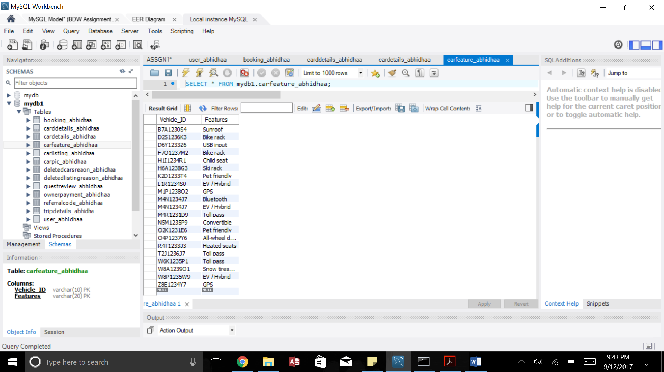

1. CarListing_AbhidhaA: This table stores the details of the listed car and their respective owner IDs.

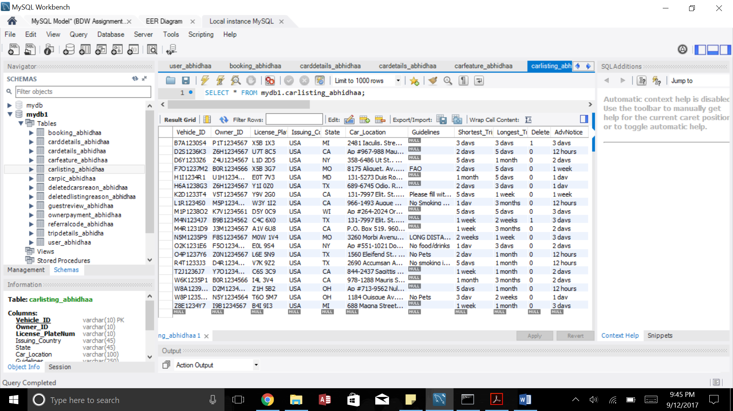

1. CarPic_AbhidhaA: This table stores the pictures of the car if uploaded. Images cannot be stored in a database hence the path of the image is stored as BLOB datatype.

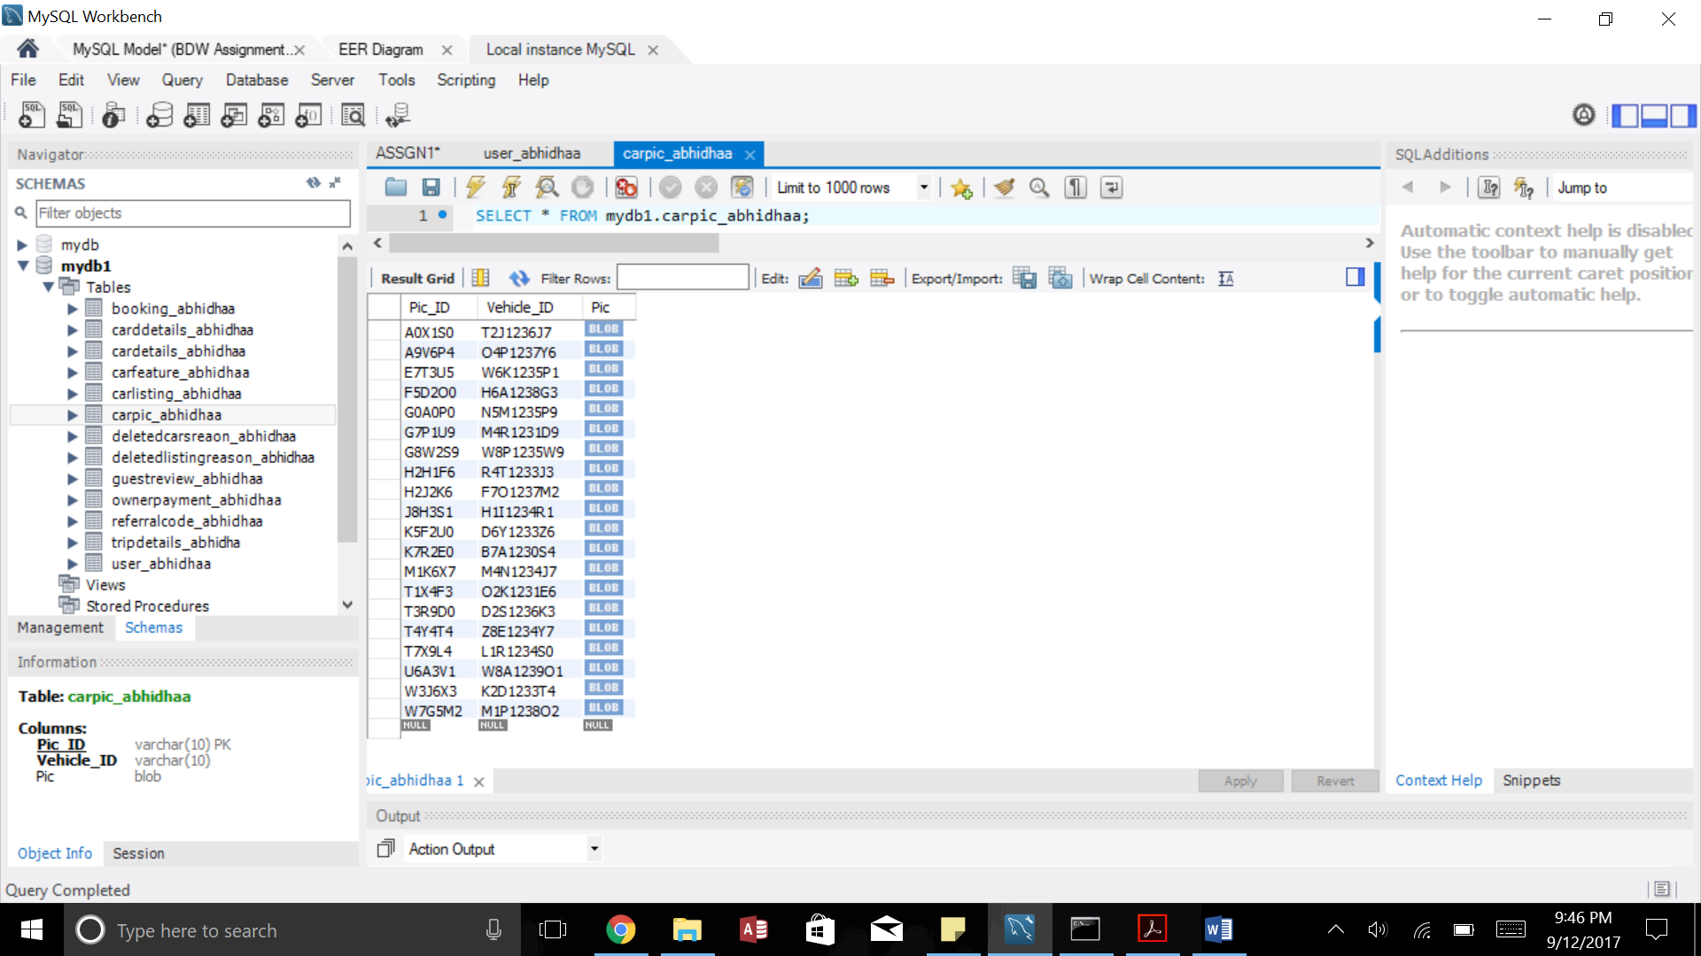

1. DeletedCarReason_AbhidhaA: This table stores the cars which are deleted with their respective reasons.

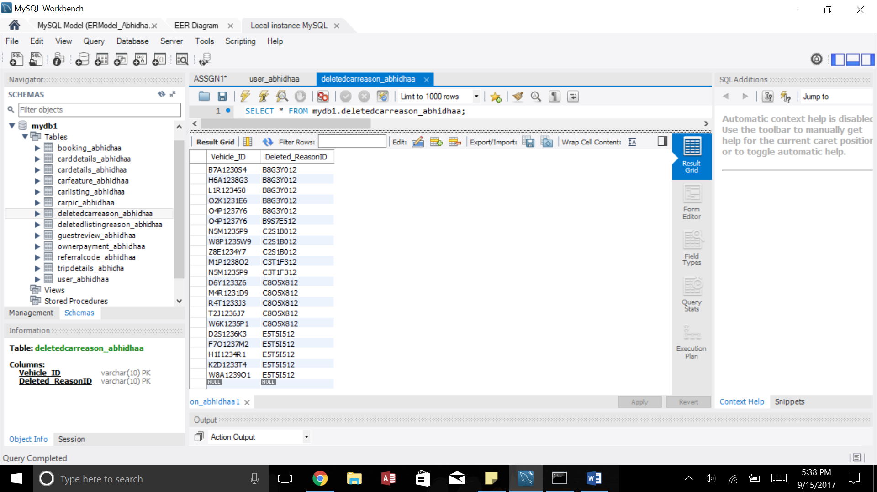

1. DeletedListingReason_AbhidhaA: This table contains the reasons of deleting a listing.

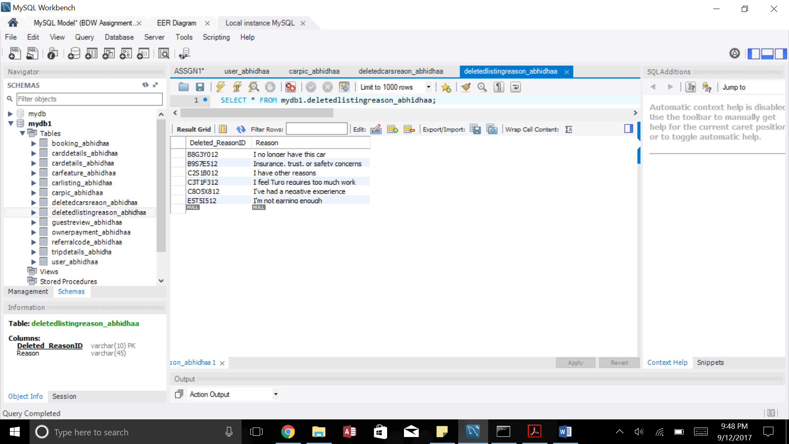

1. GuestReview_AbhidhaA: This table stores the reviews and ratings given by the guests.

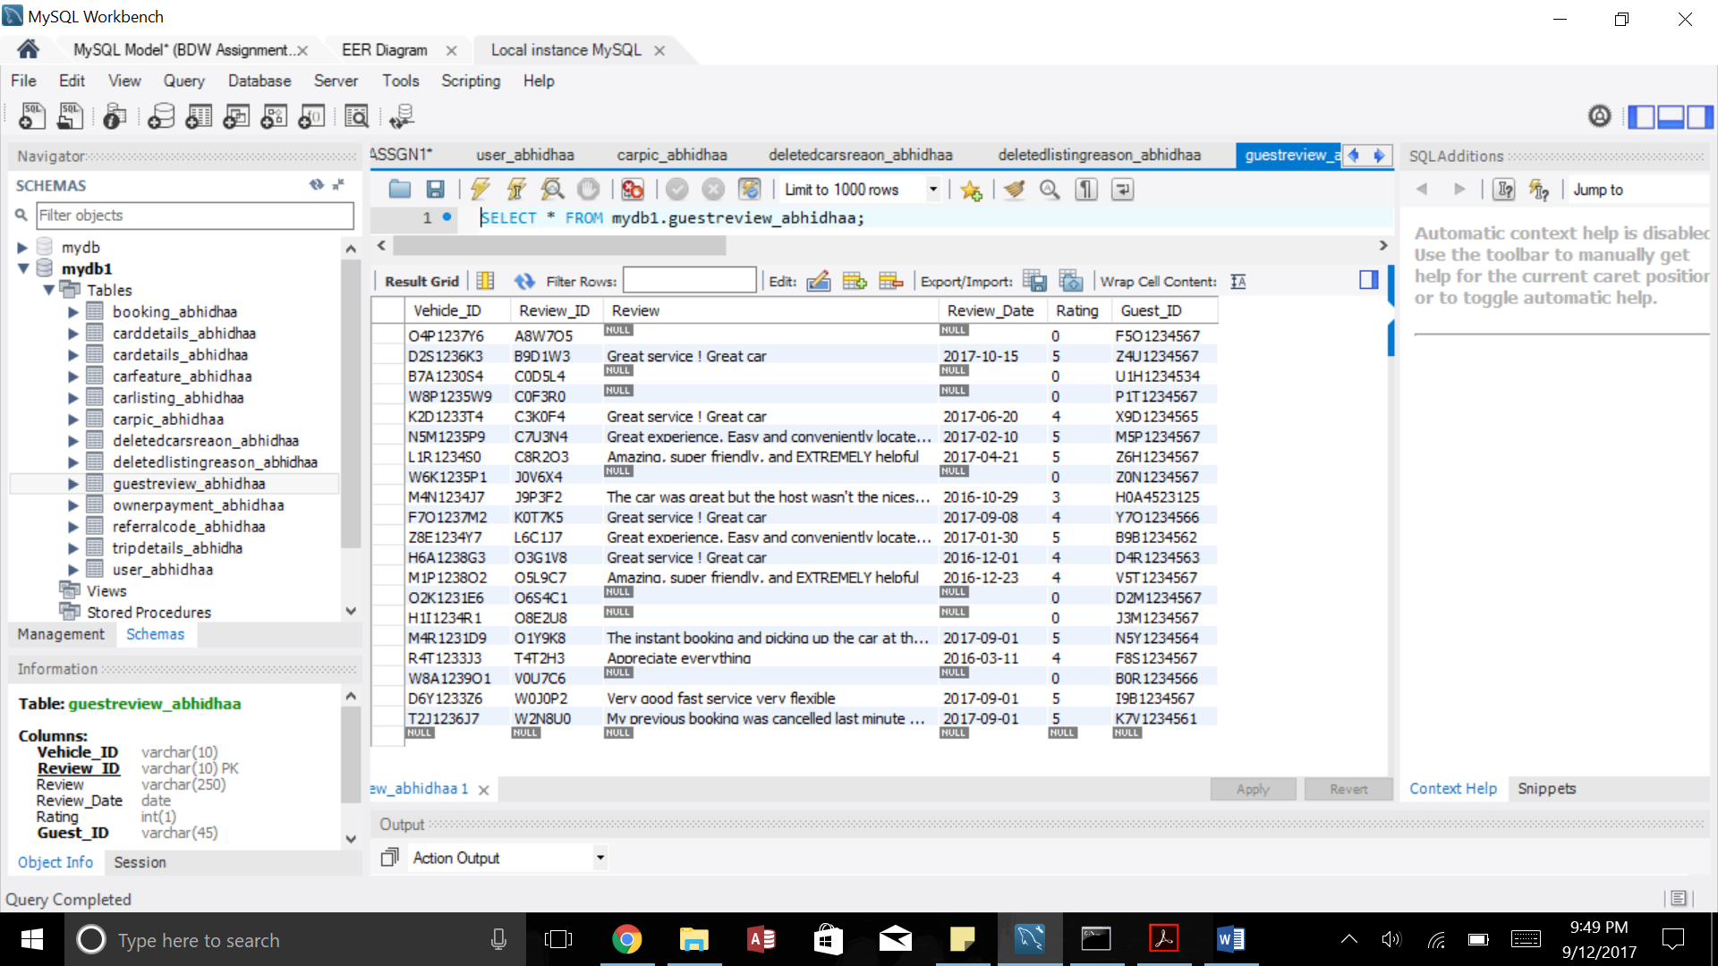

12. OwnerPayment_AbhidhaA: This table stores the Payment received by the owner after a trip.

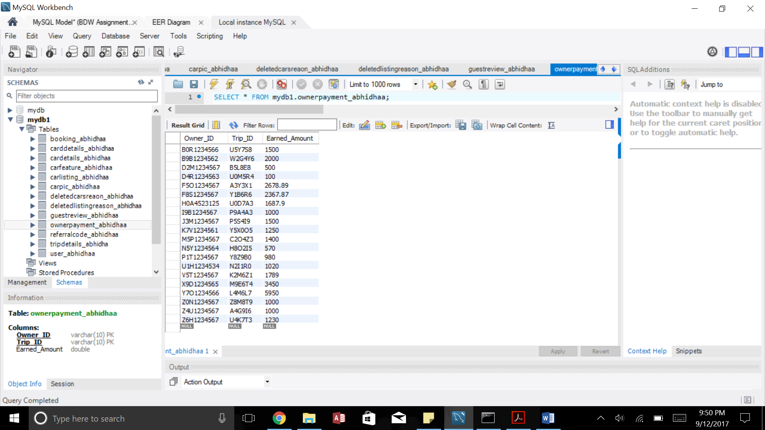

1. TripDetails_AbhidhaA: This table stores the details of a trip.

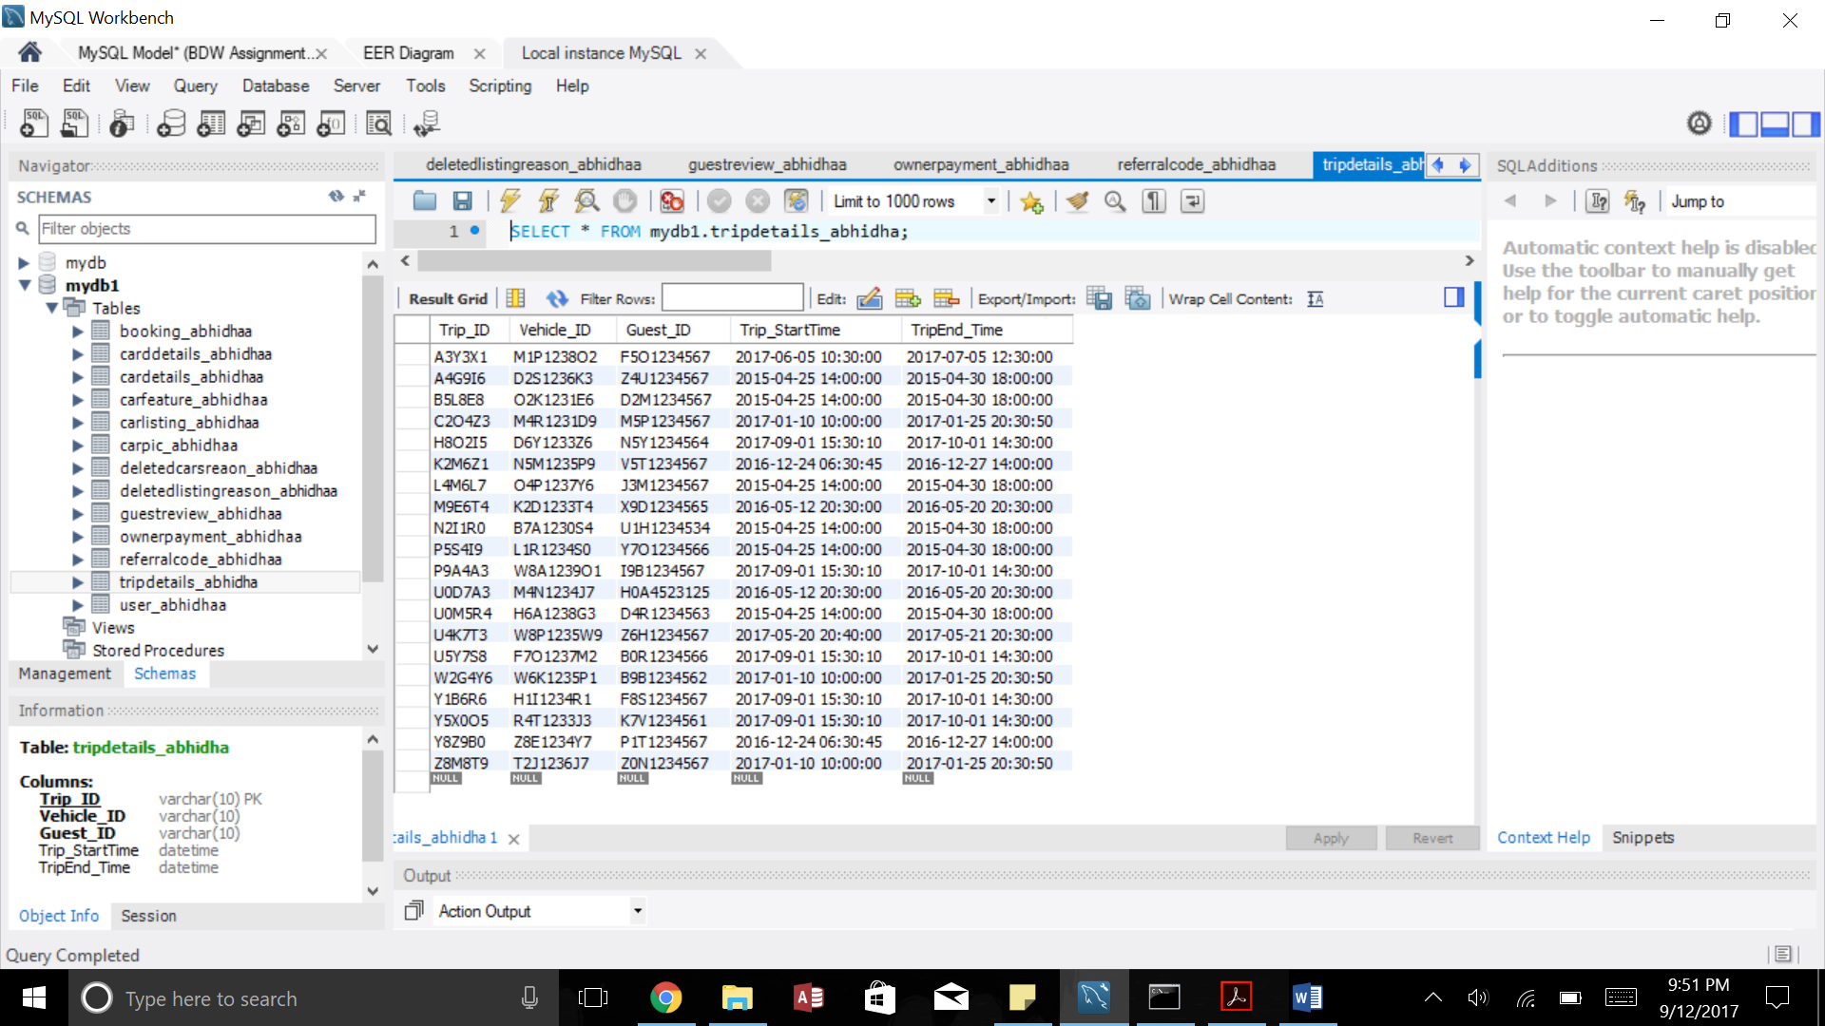

1. ReferralCode_AbhidhaA: This table stores the referral amount earned by users.

